Experiment: Decision Tree using ID3 Algorithm
Aim
To implement and demonstrate the Decision Tree using the ID3 Algorithm and classify a new sample using the generated decision tree.
Theory
The ID3 (Iterative Dichotomiser 3) algorithm is a supervised machine learning algorithm used to build a Decision Tree for classification.
It selects the best attribute based on Information Gain, which is calculated using Entropy.
- Entropy measures the impurity of the dataset.
- Information Gain measures how well an attribute separates the data.
The attribute with the highest Information Gain is selected as the root node.
Algorithm
- Read the training dataset.
- Calculate the entropy of the dataset.
- Compute the Information Gain for every attribute.
- Select the attribute with the highest Information Gain as the root node.
- Repeat the process recursively for each branch.
- Build the decision tree.
- Predict the class label for a new sample
Dataset (playtennis.csv)
Create a file named playtennis.csv.
csv
Outlook,Temperature,Humidity,Wind,PlayTennis
Sunny,Hot,High,Weak,No
Sunny,Hot,High,Strong,No
Overcast,Hot,High,Weak,Yes
Rain,Mild,High,Weak,Yes
Rain,Cool,Normal,Weak,Yes
Rain,Cool,Normal,Strong,No
Overcast,Cool,Normal,Strong,Yes
Sunny,Mild,High,Weak,No
Sunny,Cool,Normal,Weak,Yes
Rain,Mild,Normal,Weak,Yes
Sunny,Mild,Normal,Strong,Yes
Overcast,Mild,High,Strong,Yes
Overcast,Hot,Normal,Weak,Yes
Rain,Mild,High,Strong,No
Python Program
import pandas as pd
from sklearn.preprocessing import LabelEncoder
from sklearn.tree import DecisionTreeClassifier, export_text
# Load the dataset
data = pd.read_csv("playtennis.csv", sep=",")
print("Training Dataset:\n")
print(data)
# Separate features and target
X = data.iloc[:, :-1].copy()
y = data.iloc[:, -1]
# Encode categorical data
encoders = {}
for column in X.columns:
le = LabelEncoder()
X[column] = le.fit_transform(X[column])
encoders[column] = le
target_encoder = LabelEncoder()
y = target_encoder.fit_transform(y)
# Create Decision Tree using ID3 (Entropy)
model = DecisionTreeClassifier(criterion='entropy', random_state=0)
# Train the model
model.fit(X, y)
# Display the Decision Tree
print("\nDecision Tree:\n")
print(export_text(model, feature_names=list(X.columns))
# ------------------------------
# Predict a New Sample
# Sample:
# Outlook = Sunny
# Temperature = Cool
# Humidity = High
# Wind = Strong
# ------------------------------
new_sample = pd.DataFrame({
"Outlook": ["Sunny"],
"Temperature": ["Cool"],
"Humidity": ["High"],
"Wind": ["Strong"]
})
# Encode the new sample
for column in new_sample.columns:
new_sample[column] = encoders[column].transform(new_sample[column])
prediction = model.predict(new_sample)
print("\nPrediction for New Sample:")
print("Play Tennis =", target_encoder.inverse_transform(prediction)[0])

Output
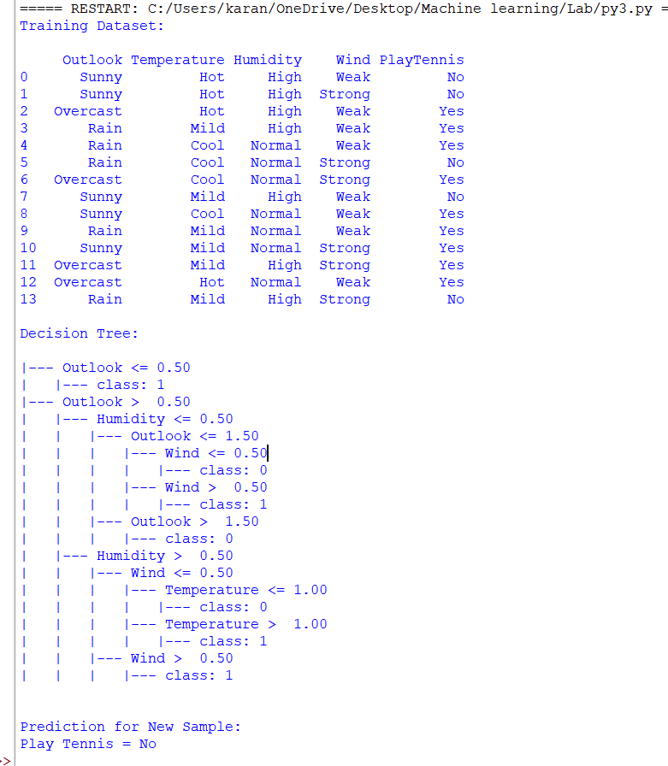
Result
The Decision Tree using the ID3 algorithm was successfully implemented. The model generated a decision tree based on the training data and correctly classified the given new sample.

